Nonlinear joint model bibliography study
As a first step of our work, we searched the PubMed articles (November 19th 2020) for studies using nonlinear joint modelling for longitudinal data and time-to-event data published between 2000 and 2020. Building on a previous systematic review on linear joint models[1], the following algorithm was used:
((model*) AND ( ("nonlinear*") OR ("non-linear*")OR (NLME*) OR (mechanistic*) OR ("non linear*") OR ("differential equation*"))AND (("mixed-effect*") OR (kinetics) OR (dynamics) OR (evolution) OR (longitudinal)) AND (("informative dropout") OR ("informative censoring") OR ("missing not at random") ))
OR
(("joint model*" OR "joint analysis" OR "joint inference") AND ((nonlinear*) OR ("non linear") OR (mechanistic*) OR (NLME*) OR (kinetics) ) AND ((longitudinal)OR (kinetics) OR (repeat* measure*) OR "mixed-effect*" OR (evolution) OR (dynamics)) AND ((survival) OR (event* time*) OR ("time-to-event") OR ("time to event") OR ("time to*")OR ("time-to*") OR (dropout) OR (risk) OR ("risk of*")))
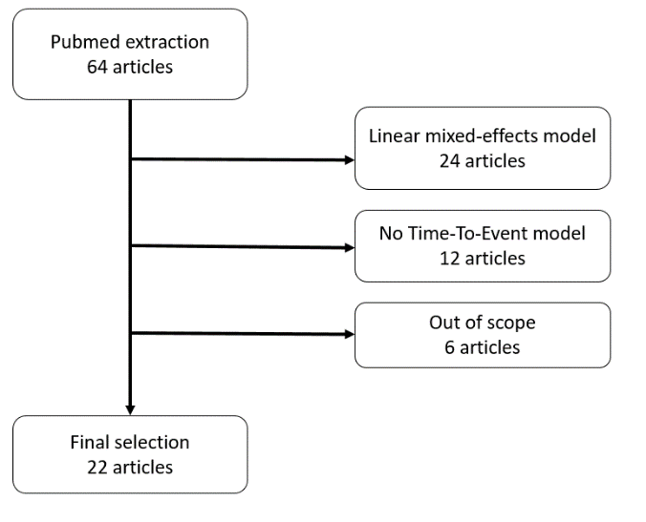
and articles were extracted if previous keywords appeared in their title or abstract.
Figure 1 Flowchart of articles extraction and selection

Toy example user guide

We provide a simulated dataset “Simulated_Dataset.txt” of tumor size longitudinal measurements and time-to-death data. Tumor size measurements were sampled every 9 weeks for almost two years (693 days), assuming a proportional error model. Time-to-death were sampled from the survival distribution conditionally to the patient’s random effects, and the events were censored if the simulated time-to-death was greater than 693 days.

Frequentist inference
This section is dedicated to the users of Monolix code at your disposal in supplementary material. You might need:
- The “Simulated_Dataset_Monolix.txt” file that contains one simulated dataset of 100 patients, which format has been adapted for a direct use in Monolix software,
- The structural model file “Joint_Monolix.txt”, containing the joint model implementation,
- The mlxtran file “Joint_Monolix.mlxtran” summarizing the parametrization of Monolix software for joint model inference.
Make sure the simulated dataset and the 2 codes are available in the same working directory. Opening the mlxtran file in Monolix software will automatically import the dataset, the structural model file, and set up the statistical model and initial values. The settings can be adjusted if needed.

Bayesian inference

This section is dedicated to the users of Stan code at your disposal in supplementary material. You might need:
- The “Simulated_Dataset.txt” file that contains one simulated dataset of 100 patients,
- The “Joint_stan.stan” code, containing the nonlinear joint model implemented in Stan programming language,
- The “Launch_stan.R” code for dataset formatting and running the Stan code via R.
Make sure the simulated dataset and the 2 codes are available in the same working directory.
The “Launch_stan.R” code can be loaded and run in R. The user specifies the path to the working directory. The code imports the simulated dataset in R, formats the data for the Stan code, imports and runs the Stan code “Joint_stan.stan”. Make sure that the rstan package is correctly installed before use. The settings can be adjusted if needed. By default, we use one core per chain but this may need to be revised depending on your computer power.

1. Sudell M, Kolamunnage-Dona R, Tudur-Smith C. Joint models for longitudinal and time-to-event data: a review of reporting quality with a view to meta-analysis. BMC Med Res Methodol. 2016;16(1):168. doi:10.1186/s12874-016-0272-6

